**Birla Institute of Technology & Science, Pilani**

**Work Integrated Learning Programmes Division**

**Second Semester 2023-2024**

**Mid-Semester Test**

**(EC-2 Regular)**

Course No. : SE ZG685

Course Title : Software Product Management

Nature of Exam : Open Book

Weightage : 30%

No. of Pages = 2

No. of Questions = 5

Duration : 2 Hours

Date of Exam : 24/09/2023 (FN)

Note to Students:

1. Please follow all the *Instructions to Candidates* given on the cover page of the answer book.
2. All parts of a question should be answered consecutively. Each answer should start from a fresh page.
3. Assumptions made if any, should be stated clearly at the beginning of your answer.

**Highway Delite software product description**

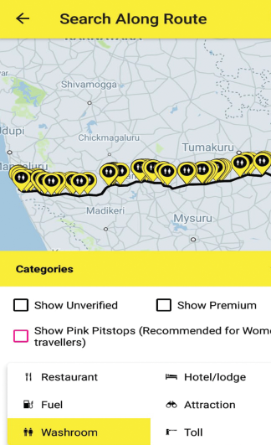

Highway Delite is a software platform that allows highway travelers to discover facilities along the highway – facilities such as restaurants, dhabas, washrooms, fuel pumps, hotels, mechanics, ATMs, hospitals and more. It offers real-time location based information about these services and also allows travelers to transact with these services (service providers).

It covers more than 60,000 kms of highways pan India and have more than 1 lakh verified data points.

The product received Grant funding from the Department of Tourism, Karnataka and Bharat Petroleum.

a) Design 3 open-ended questions to be asked to the potential customers to assess the value of Highway Delite product described above. [3]

b) Illustrate the bottom 3 layers of product-market fit pyramid of Highway Delite product described above. [3]

c) Create a Lean canvas & Story map for the Highway Delite product described above [3+3]

d) Rate the 4 types of risks of Highway Delite product on a scale of 1 to 10. Justify your rating of each type of risk. [4]

1. Classify the features of your online banking software using Kano Model. Justify your classification. [2]
2. Assume Bounce (Scooter rental) is at a startup stage. Mention 2 types of MVPs that can be considered for this product. Explain why these 2 MVPs are the most suitable for this product. [3]
3. What kind of pivot would you introduce when you discover that the product you have launched is not being purchased by sufficient customers but you feel that the product with a little modification might do well in a different target market? Give an example of such as product and pivot. [3]
4. We would like to develop a unified user interface for all messaging applications namely SMS, WhatsApp, Email. From the unified user interface one should be able to access messages from all these applications. Using the Sprint technique

* Map the usage of the product [2]
* Identify the top 2 HMW questions (How May We questions) (key questions that need to be answered to make the solution effective) [2]
* Explain the User interface of the solution [2]

****